MEDIA RELEASE
25 February 2019

Kazerne opens fine dining restaurant with Nordic touch

Culinary rockers Olander and Tonglet join forces in Eindhoven

Eindhoven – With the arrival of Nik Tonglet (De Houtloods) in Eindhoven, the kitchen team at Kazerne's second restaurant is now complete. Together with Mark Groenendaal, who has been part of the Kazerne team before, and led by the young Swedish chef Rasmus Olander (Geranium***), these culinary 'rockers' will be offering a unique gastronomic experience with a Scandinavian touch from 9 March. In this new, intimate restaurant, Kazerne also aims to inspire and connect with fine dining enthusiasts. The name of the restaurant is still being pondered upon.

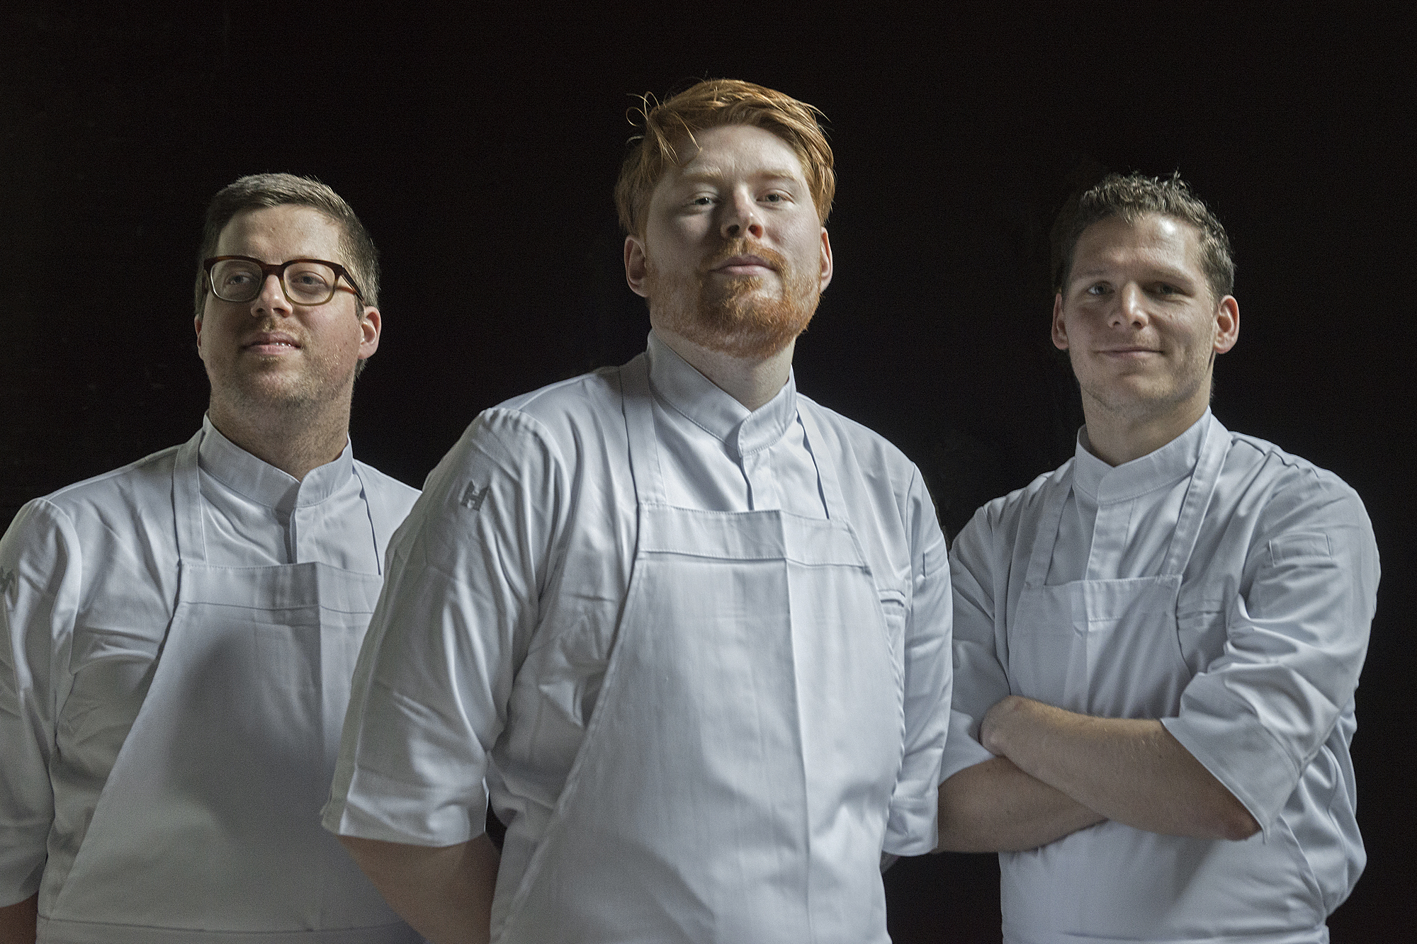

The culinary rockers at Kazerne's second restaurant. from L to R: Mark Groenendaal, Rasmus Olander, Nik Tonglet; photo: Ruud Balk

As home of design, Kazerne considers experimentation to be of the paramount importance. After all, that is precisely how innovation comes about. Olander: “I look forward to rethinking familiar tastes, textures and techniques with the new crew and to creating new dishes together. We are taking the time to develop our own signature. Based on Nordic tradition, we are inspired by seasonal, local ingredients and authentic preparation methods”.

Similar to a rock band in which the lead singer and guitarist excel at working together with the drummer, this new restaurant is all about the synergy of the team. Each person has their own, indispensable, role in achieving an optimal culinary experience.

Only 23 years of age, Swedish talent Rasmus Olander has been working as a cook since 2012. Cosmopolitan by nature, he previously worked at Kommilfoo* in Antwerp and Geranium*** in Copenhagen, where chef Kofoed was the only one in the world ever to win all the Bocuses d'Or. Since 2017, Olander has been a part of leading international cooking competitions as a member of the Swedish Junior Culinary Team, where he has made friends for life.

Nik Tonglet from Tilburg is a fast-rising star in the Dutch culinary field: within one year of working as the chef of De Houtloods, he acquired both a Bib Gourmand and a mention in the leading magazine ‘top 100 Lekker’ [Tasty]. He was educated in South Africa and gained experience with the best of the best, including The Test Kitchen in Cape Town, The Fat Duck*** in Bray, England, and Noma** in Copenhagen.

Mark Groenendaal has previously worked in Kazerne and is known to be a curious cook. He forms the lynchpin between the new kitchen and the industrial restaurant, which was opened in 2014. In that restaurant, led by Giovanni Gabanna, guests are welcome seven days a week to view the exhibition and to have lunch, drinks and dinner with an Italian touch.

The fine dining restaurant is opening in the recently renovated coach house of the former military police barracks, which was also used by the fire brigade for a number of years. Led by founders Annemoon Geurts and Koen Rijnbeek, this was recently transformed into an intimate, luxurious design space with soft earthy colours, rich materials and leading designs with great attention to original beauty.

Curious? The high end restaurant will be open five days a week, from Tuesday to Saturday. It is possible to reserve a table in advance for a date from Saturday 9 March via info@kazerne.com. For more information, please visit www.kazerne.com

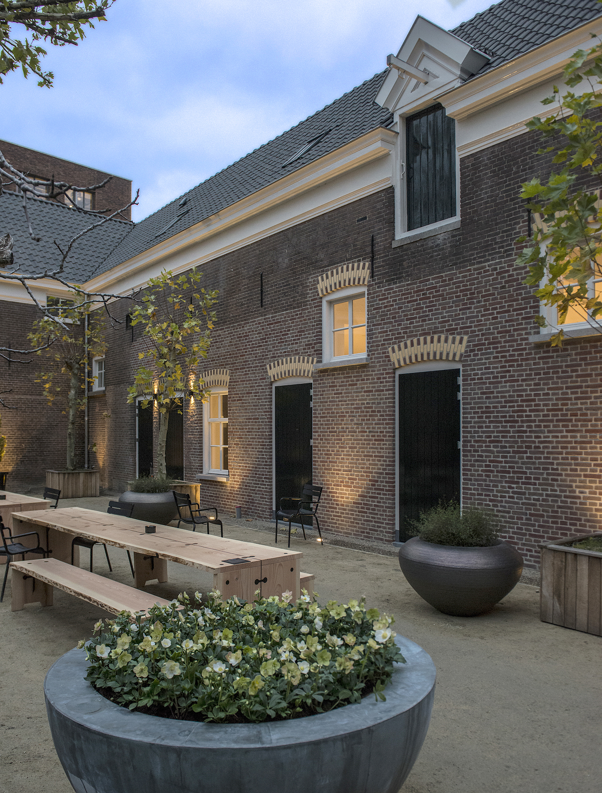
ABOUT KAZERNE
Eindhoven, an important city within the international design field, now offers a unique design and hospitality experience: Kazerne - Home of Design. Located in former military police barracks and the adjacent industrial warehouse, Kazerne celebrates the impact of design by welcoming you to eat, drink and stay overnight surrounded by recent works by world-class design talents. Renovated with great attention paid to its original beauty, the heritage building has 2,500 square metres of exhibition space (with exhibitions changing every four months), and includes eight luxury hotel rooms and lofts, several meeting rooms, a design shop and two restaurants. The industrial, lively bar/bistro with an Italian touch opened in 2014. The new fine-dining restaurant with a Nordic touch opens in March 2019. Imagine a museum platform, against a backdrop of monumental heritage, that has been transformed into a breathtaking hotel. “This is where guests meet the local creative community. Here, in an inspiring and atmospheric environment, conversations about food and design take place naturally”, explains Co-creator and Creative Director Annemoon Geurts. Kazerne offers an environment like no other where guests can experience 24/7 how design adds value to the world we live in.

NOTE FOR EDITOR - not for publication

Press release and royalty-free high-res images can be downloaded via: http://kazerne.com/press
Additional images and interviews are available on request. Please contact Annemoon Geurts via +316 22529413 or mail to communications@kazerne.com

